Sum-Meet
Use Case Specification

Submitted to:

Asst. Prof. Ma. Rowena C. Solamo
Faculty Member
Department of Computer Science
College of Engineering
University of the Philippines, Diliman

Submitted by:
Batula, Bryce Spencer
Bayuga, Michael John
Yap, John Theodore

In partial fulfillment of academic requirements
for the course
CS 191 Software Engineering I
of the
1st Semester, AY 2015-2016
Unique Reference:
The documents are stored in https://github.com/trackertech568/CS191-Batula-Bayuga-Yap.
[File Reference in GitHub, preferably link.]

Document Purpose:
To show the flow of events of a use-case from its diagram.

Target Audience:
Meeting organizers.

Revision Control

History Revision:
Revision Date | Person Responsible | Version  Number | Modification
09/18/15 | Batula, Bryce  Bayuga, Michael  Yap, John Theodore | 1.0 | Initial Document; Version number should match the one found in the footer.

Use-Case Name: 3.0 Update

Description: Attendee will update his/her answer for the meeting. Either it is his/her first answer or not. The meeting organizer will be notified for the changes.

Preconditions: NONE

Flow of Events:
Scenario Name | Description
Scenario 1 (Basic Flow)  Attendee will reply for the meeting. | 1. System will send a notification to the attendee for a meeting  2. System should find out if the attendee already confirms the notification or not.  3. If there is none, attendee will reply for confirmation.  4. System will update attendees’ list depending on the answer.  5. System notifies meeting organizer.
Scenario 2  Attendee will update the answer if there are some changes. | 1. System will send a notification to the attendee for a meeting  2. System should find out if the attendee already confirms the notification or not.  3. If there exist, attendee will reply for changes  4. System will update attendees’ list depending on the answer.  5. System notifies meeting organizer.

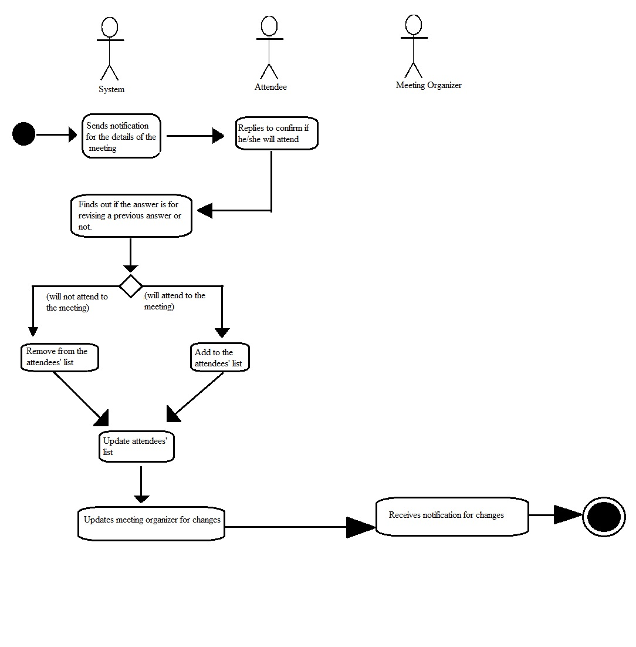

Activity Diagram of the Flow of Events:

Postcondition: NONE

Relationships: NONE

Special Requirements: NONE

